**Employee Data Analysis using Excel**

*STUDENT NAME: B. S. Sanjay*

*REGISTER NO: 312211988*

*NM NO: F6E34BA85909E0CB87B460571B860D76*

*DEPARTMENT: B.COM (General)*

*COLLEGE: MAR GREGORIOS COLLEGE OF ARTS AND SCIENCE*



**PROJECT TITLE**



***Employee Performance Analysis***

***Using Excel***

3

/21/2024

**Annual Review**



**AGENDA**

*1.*

*Problem Statement*

*2.*

*Project Overview*

*3.*

*End Users*

*4.*

*Our Solution and Proposition*

*5.*

*Dataset Description*

*6.*

*Modelling Approach*

*7.*

*Results and Discussion*

*8.*

*Conclusion*

*To write a problem statement on employee performance, you need to identify the specific area of performance that is problematic, such as low productivity, high absenteeism, or poor quality of work.*

*Objective: Improve the effectiveness of the employee performance evaluation system within Company to enhance overall productivity, employee satisfaction, and alignment with organizational goals.*

*Background: The current employee performance evaluation system is perceived as subjective and inconsistent. This has led to concerns about fairness, accuracy, and its impact on employee motivation and development.*



*Identification and strengths and weakness: It helps in identifying which employees are performing well and which ones need improvements. .*

.

*Performance Metrics: It allows the organization to track key performance indicators (KPIS) such as task completion sales targets, and other measurable objectives. Informed Decision – Making: Management can make informed decision about Promotions, rewards, or additional training based on performance data*

*Resource Allocation: It helps in optimizing the allocation of resources by identifying where more support or training may be needed.*

*Employee Development: It assists in creating personalized development plans for employees, helping them grow in their roles.*

# PROJECT OVERVIEW

*Analysing the performance of the employee by considering the various factor like agenda, performance, achievements etc. The employee performance analysis project aims to assess and enhance productivity by evaluating key performance metrics and competencies. It will involve collecting data through surveys, evaluations, and performance indicators over a defined period. The analysis will identify strengths, areas for improvement, and alignment with organizational goals. Key stakeholders include employees, managers, and HR personnel. The project will culminate in actionable insights and recommendations to support professional development and performance improvements. This project overview helps to identify the trends and patents of different categories of employees like high, medium, low, etc. The employee performance analysis using excel project aims to evaluate and improve employee productivity within an organization by leveraging excels data analysis and visualization capabilities. The project involves collecting relevant performance data such as attendance, task completion rates, and sales figures, and organizing this information into a structured excel workbook. Using various excel functions and tools, the data will be analysed to identify trends, Strengths, and areas needing an improvement.*



**WHO ARE THE END USERS?**

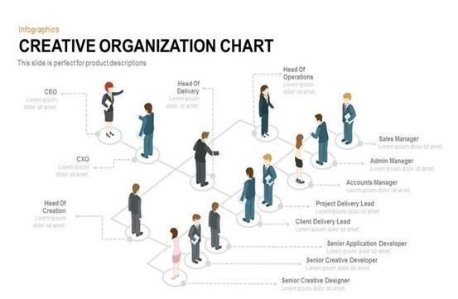

***Management:*** *They will gain insights into employee productivity and performance trends, helping them make informed decisions about promotions, rewards, and resource allocation.*

* ***HR Department:*** *HR professionals can use the analysis to identify training needs, develop personalized development plans, and ensure fair and data-driven performance evaluations.*
* ***Employees:*** *Employees will benefit from clear feedback on their performance, leading to opportunities for growth, recognition, and career advancement.*
* ***Team Leaders:*** *They can use the analysis to understand team dynamics, identify top performers, and address any performance issues within their teams.*
* ***The Organization as a Whole:*** *By optimizing employee performance and productivity, the organization can achieve better overall efficiency, reduce costs, and improve employee satisfaction and re*tention.

## OUR SOLUTION AND ITS VALUE PROPOSITION

*Conditional formatting - missing*

*Filter - remove*

*Formula - performance*

*Pivot - summary*

*Graph- data visualization*

# Dataset Description

*Employee=tony stark*

*26- Features*

*9-features*

*Employee ID number-3435*

*NAME-TEXT-Calibri*

*Business Unit-STKI*

*Job Function- Engineer*

*Gender-Male*

*Employee rating number-5*

*Performance Score-Fully Meets*

## THE "WOW" IN OUR SOLUTION

3

/21/2024

**Annual Review**



• *Performance level =IFS (Z11>=5,"very high", Z11>=4,"high", Z11>=3,"medium", TRUE, "low")*

# MODELLING

***1. Data Collection and Entry:***

•***Sheet*** in***:*** *This sheet contains detailed employee information, including Employee ID, names, start dates, job titles, supervisors, email addresses, business units, and performance-related data. This is the primary data source for my analysis.​* ***2. Data Preparation:***

•***Sheet*** in***:***

•*I have gathered comprehensive employee data, possibly from various sources, and compiled it into this sheet.​*

•*The data includes demographic information, job details, and performance metrics like "Performance Score" and "Employee Rating."​*

•*This sheet also has a "Performance level" column, though some values appear to be missing.​*

***3. Aggregation of Performance Data:***

•***Sheet*** Sheet1***:*** •*This sheet appears to summarize performance data by Business Unit.​*

•*The table is organized to show the count of employees in each performance level (high, low, medium, very high) across different Business Units (e.g., BPC, CCDR).​* •*I used Excel functions like* counter *fort* Pivot Tables *to aggregate this data.*

•*The sheet also includes a "Grand Total" column, which summarizes the total count of employees across performance levels for each Business Unit.​*

# MODELLING

1. ***Visualization:***

•*Although not explicitly shown in the provided data, it’s common to create charts or graphs in Excel to visualize performance distributions.*

•*I have used the data in Sheet1 to create bar charts or pie charts illustrating the distribution of performance levels across different Business Units.*

1. ***Additional Data Analysis (Sheet2):***

•***Sheet Sheet2:***

•*Contains ID-marks pair, possibly related to some other aspect of performance or another dataset.*

•*It might be used for supplementary analysis, though it’s unclear how it ties into the main performance analysis.*

1. ***Final Analysis and Reporting:***

•*I would likely compile these analyses into a coherent report, possibly adding explanations, visualizations, and insights directly into the Excel file or exporting the data into a presentation format.*

•*Key insights could include identifying top-performing Business Units, areas needing improvement, and employee distribution across performance levels.*

# RESULTS

Employee Performance Analysis

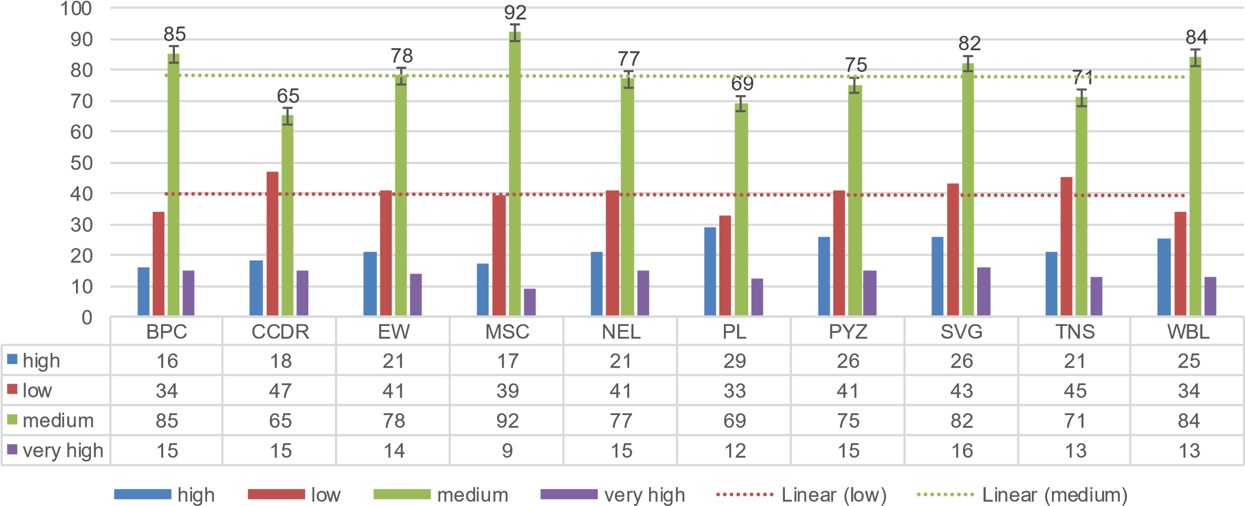

# RESULT

|  |  |
| --- | --- |
| Gender Code | (All) |

|  |  |  |  |  |  |  |
| --- | --- | --- | --- | --- | --- | --- |
| **Count of First Name** | **Performance level** | | | | | |
| **Business Unit** | **high** | **medium low m very high Grand Total** | | | | |
| BPC |  | 16 | 34 | 85 | 15 | 150 |
| CCDR |  | 18 | 47 | 65 | 15 | 145 |
| EW |  | 21 | 41 | 78 | 14 | 154 |
| MSC |  | 17 | 39 | 92 | 9 | 157 |
| NEL |  | 21 | 41 | 77 | 15 | 154 |
| PL |  | 29 | 33 | 69 | 12 | 143 |
| PYZ |  | 26 | 41 | 75 | 15 | 157 |
| SVG |  | 26 | 43 | 82 | 16 | 167 |
| TNS |  | 21 | 45 | 71 | 13 | 150 |
| WBL |  | 25 | 34 | 84 | 13 | 156 |
| **Grand Total** |  | **220** | **398** | **778** | **137** | **1533** |

High

BPC

CCDR

EW

MSC

NEL

PL

PYZ

SVG

TNS

WBL

# Conclusion

*The Employee Performance Analysis reveals varied performance levels across different Business Units, with a significant number of employees falling into the "medium" and "low" categories, particularly in units like BPC and CCDR. There are also strong performers in the "very high" category, suggesting potential for leadership development. However, some data gaps, such as missing "Performance level" entries, need addressing for more accurate insights. Overall, the analysis suggests a need for targeted training and development in lower-performing units, recognition programs for high performers, and improved data accuracy for future assessments.*